Procedure to install new plugin in Jenkins

1. Goto to Jenkins URL
2. Login to Jenkins .

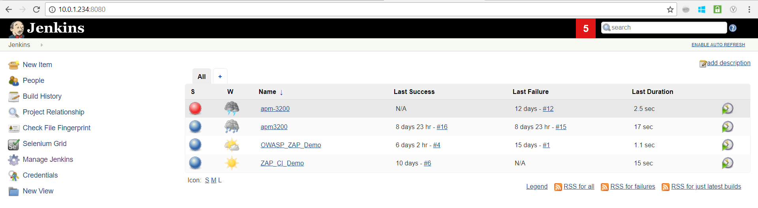

1. Click on Manage Jenkins

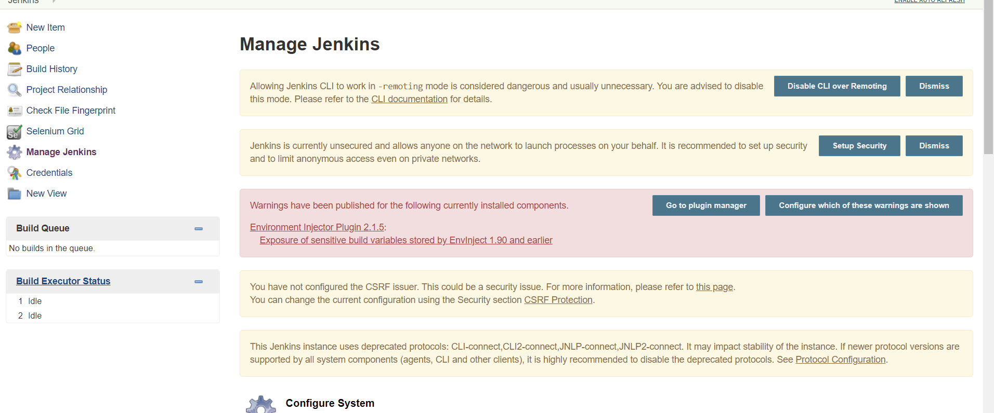

1. Click on Manage Plugins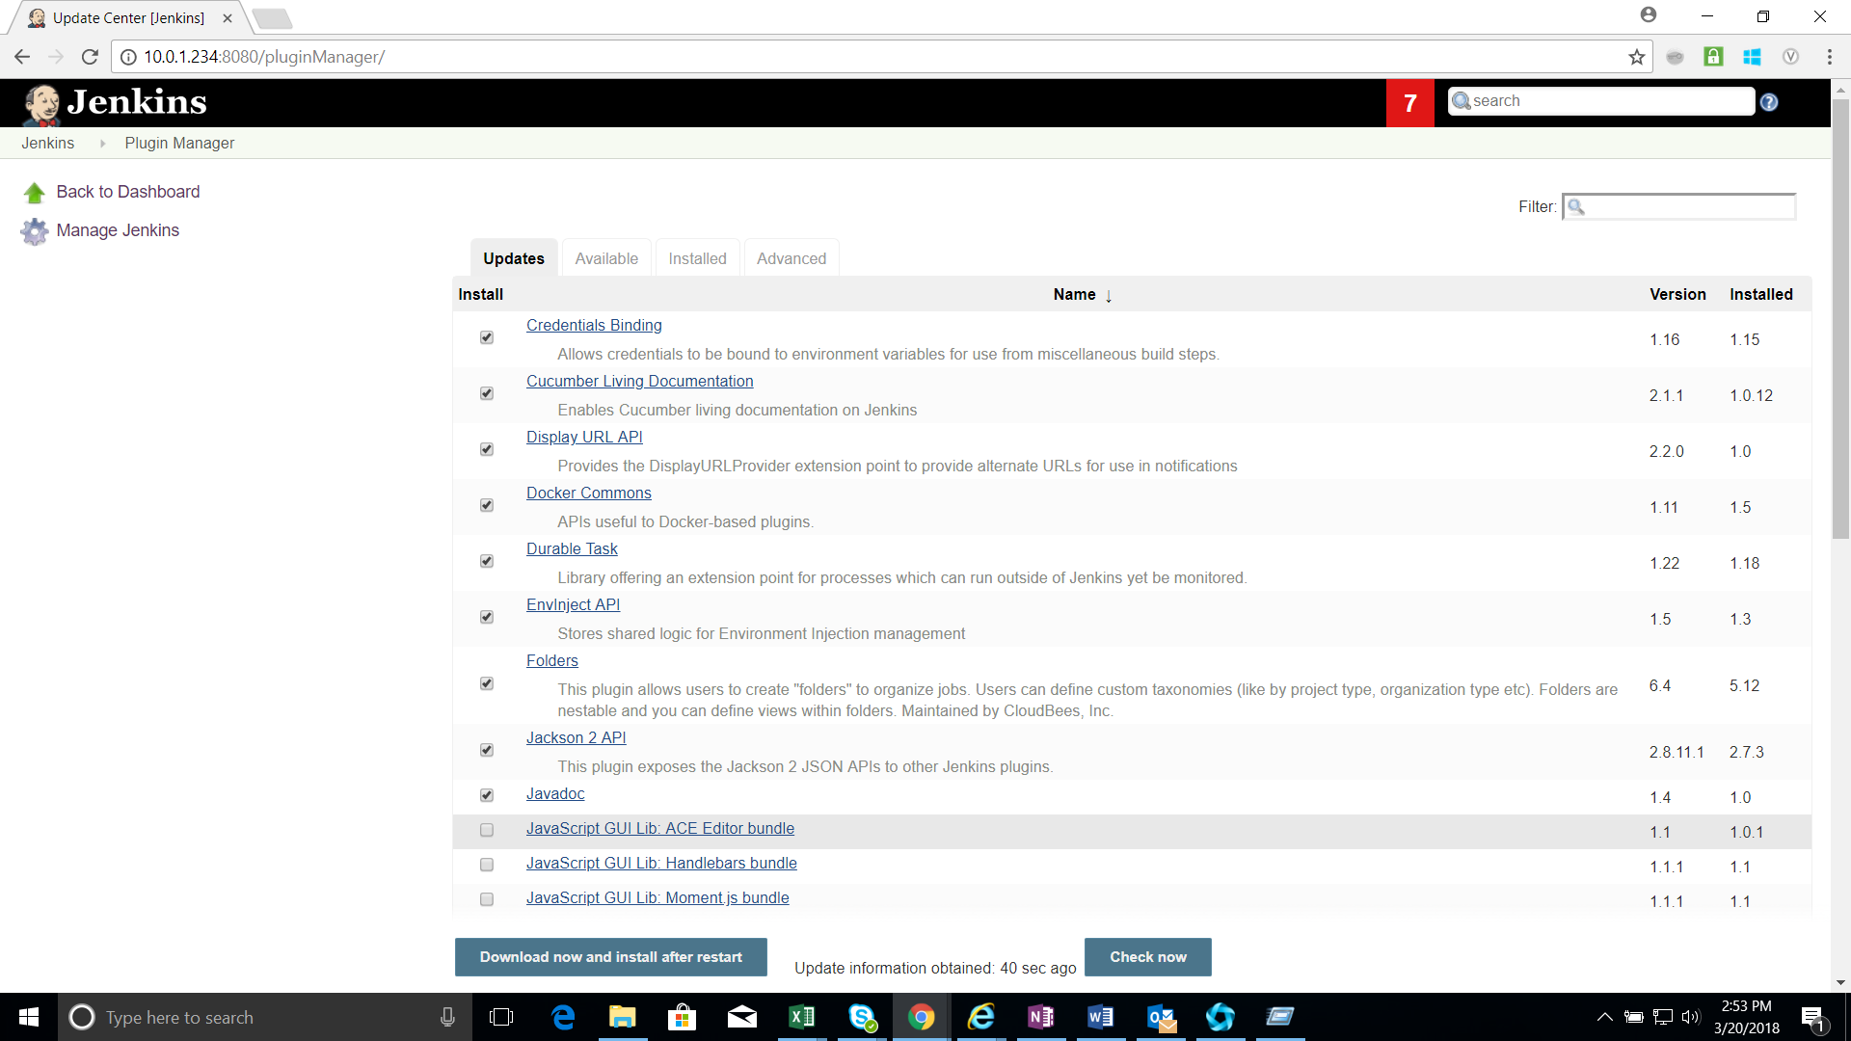
2. Click on Available tab .

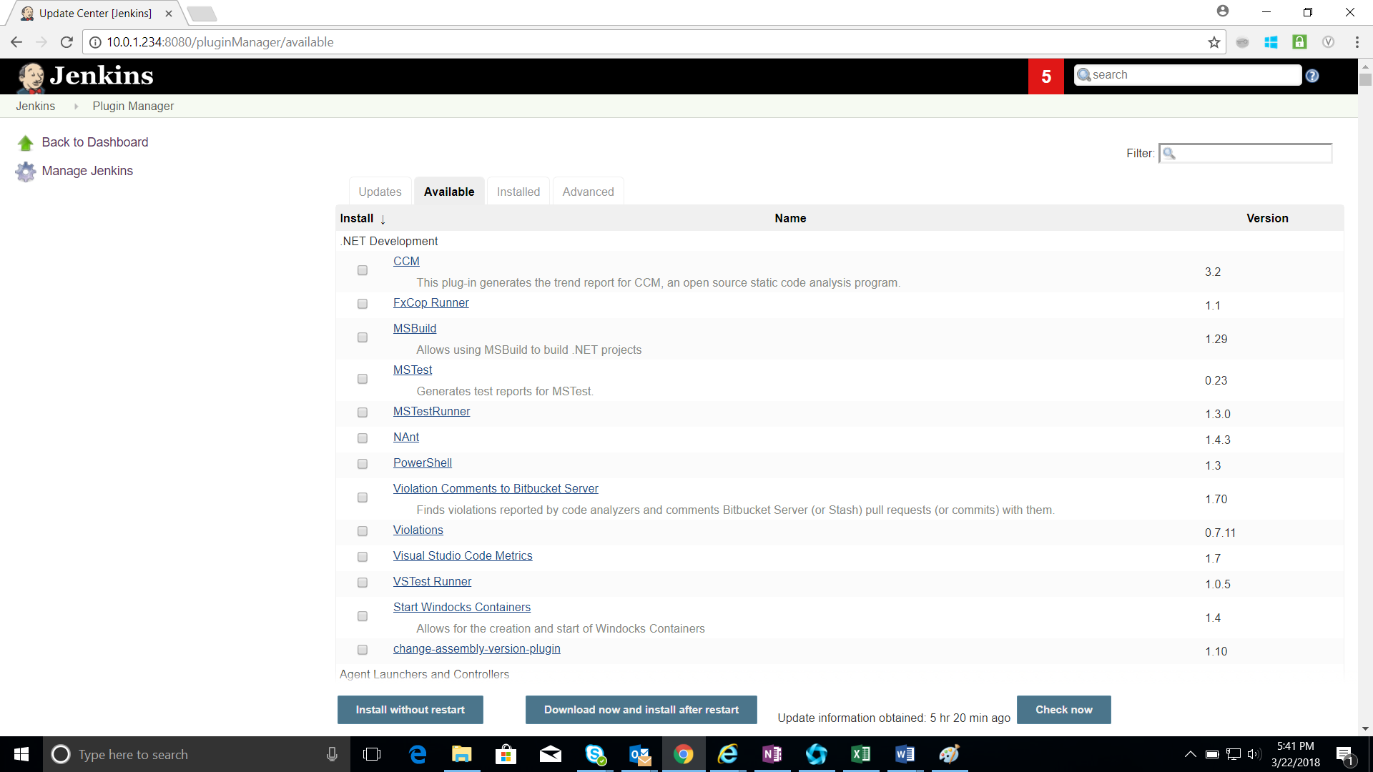

1. Search the plugin required and click on install without restart

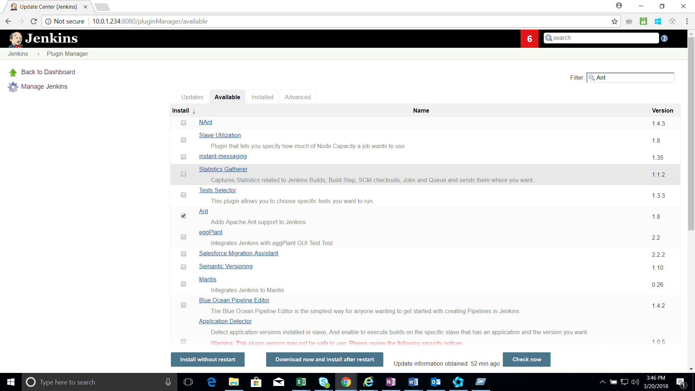

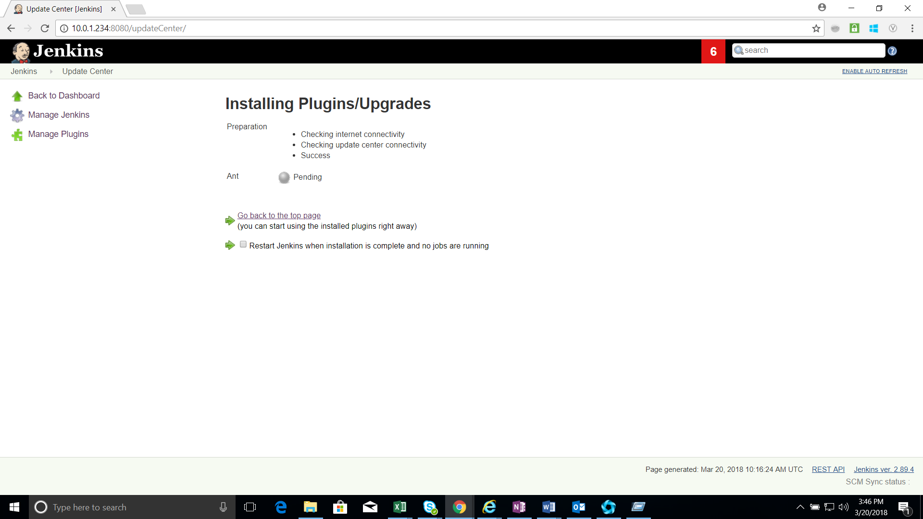

1. Once the installation is complete you will see a success message .

